Name of Student: Aman Srivastava

Reg. No.: 20BCE10873

Slot: Internet and web programming

**Experiment-2: Design an English alphabet chart**

**HTML & CSS CODE**

<h4>Name of Student: Aman Srivastava</h4>

<h4>Reg No.: 20BCE10873</h4>

<!DOCTYPE html>

<html lang="en">

  <head>

    <meta charset="UTF-8" />

    <meta http-equiv="X-UA-Compatible" content="IE=edge" />

    <meta name="viewport" content="width=device-width, initial-scale=1.0" />

    <title>Alphabet Table</title>

  </head>

  <body>

    <div

      style="

        margin-top: 20px;

        font-size: 30px;

        color: black;

        font-family: 'Gill Sans', 'Gill Sans MT', Calibri, 'Trebuchet MS',

          sans-serif;

      "

    >

      <b>

        <*center*>ALPHABET TABLE</*center*>

      </b>

    </div>

    <div style="margin-top: 30px">

      <img

        src="https://www.apple.com/newsroom/images/product/apps/standard/Apple-App-Store-Awards-2022-Trophy_inline.jpg.large.jpg"

        alt="Apple"

        usemap="#A"

        style="height: 233px; width: 216px; margin-right: 31px"

      />

      <img

        src=" https://st3.depositphotos.com/1561359/12975/i/600/depositphotos_129758556-stock-photo-3d-green-letter-b.jpg"

        alt="Ball"

        usemap="#B"

        style="height: 233px; width: 216px; margin-right: 31px"

      />

      <img

        src="https://encrypted-tbn0.gstatic.com/images?q=tbn:ANd9GcT1FIChP4eBN6tpRPdgAXkUN4JScstcm5zeZ1-lszxl&s"

        alt="Cat"

        usemap="#C"

        style="height: 233px; width: 216px; margin-right: 31px"

      />

      <img

        src="https://previews.123rf.com/images/iunewind/iunewind1202/iunewind120200086/12668922-letter-d-alphabet-of-green-leaves.jpg"

        alt="Dog"

        usemap="#D"

        style="height: 233px; width: 216px; margin-right: 31px"

      />

      <img

        src="https://encrypted-tbn0.gstatic.com/images?q=tbn:ANd9GcTmA330ienoPe2vRlB9tooBbE37ucagdNQKP1aMNJM&s"

        alt="Elephant"

        usemap="#E"

        style="height: 233px; width: 216px; margin-right: 31px"

      />

      <img

        src="https://images.unsplash.com/photo-1547387557-21339915455f?ixlib=rb-4.0.3&ixid=MnwxMjA3fDB8MHxwaG90by1wYWdlfHx8fGVufDB8fHx8&auto=format&fit=crop&w=435&q=80"

        alt="Fish"

        usemap="#F"

        style="height: 233px; width: 216px; margin-right: 31px"

      />

      <img

        src="https://st3.depositphotos.com/1561359/12975/i/450/depositphotos_129758586-stock-photo-3d-green-letter-g.jpg"

        alt="Giraffe"

        usemap="#G"

        style="height: 233px; width: 216px; margin-right: 31px"

      />

      <img

        src="https://i.pinimg.com/originals/a7/2d/83/a72d83e881fadfcb00790cb959cfd36e.png"

        alt="Horse"

        usemap="#H"

        style="height: 233px; width: 216px; margin-right: 31px"

      />

      <img

        src="https://as2.ftcdn.net/v2/jpg/02/23/81/25/1000_F_223812536_u728skTbXVdjSoppOLU2KoTvJ1PmNqa7.jpg"

        alt="Ice"

        usemap="#I"

        style="height: 233px; width: 216px; margin-right: 31px"

      />

      <img

        src="https://cdn3.iconfinder.com/data/icons/letters-and-numbers-1/32/letter_J_red-512.png"

        alt="Joker"

        usemap="#J"

        style="height: 233px; width: 216px; margin-right: 31px"

      />

      <img

        src="https://media.istockphoto.com/id/175174012/photo/varsity-college-letter-k.webp?s=612x612&w=is&k=20&c=j5gx6xWpZ-RyHPznNoCD-ejfQ_pYEMhpKTfP2-RaJZ4="

        alt="King"

        usemap="#K"

        style="height: 233px; width: 216px; margin-right: 31px"

      />

      <img

        src="https://media.istockphoto.com/id/1336351598/photo/letter-l-with-pink-fluffy-hairy-fur-uppercase.webp?s=612x612&w=is&k=20&c=XxwWLpa-UBC-zKN-ODI3X-LDMz0ftY267ZeKj6Ulyko="

        alt="Lion"

        usemap="#L"

        style="height: 233px; width: 216px; margin-right: 31px"

      />

      <img

        src="https://media.istockphoto.com/id/1360558076/photo/letter-m-decorated-with-light-bulb-covered-with-concrete.webp?s=612x612&w=is&k=20&c=_LpXvCRv2qG6FKbF5jw3X_YyEFUHWHr0iaOVHD0jvy4="

        alt="Man"

        usemap="#M"

        style="height: 233px; width: 216px; margin-right: 31px"

      />

      <img

        src="https://media.istockphoto.com/id/1378053207/photo/letter-n-red-on-white-background.webp?s=612x612&w=is&k=20&c=837UN4vaMmJ0jIeRtuq_9VReHwI9MYgo6diu_Hkpduk="

        alt="Nust"

        usemap="#N"

        style="height: 233px; width: 216px; margin-right: 31px"

      />

      <img

        src="https://media.istockphoto.com/id/1360697253/photo/letter-o-decorated-with-light-bulb-covered-with-concrete.webp?s=612x612&w=is&k=20&c=4Dx6lS0s_FYLHcgv74Y7wwAzGIE70zV9R_0xqFfIU1c="

        alt="Orange"

        usemap="#O"

        style="height: 233px; width: 216px; margin-right: 31px"

      />

      <img

        src="https://media.istockphoto.com/id/1392736153/photo/red-metallic-letter-p-with-light-bulbs.webp?s=612x612&w=is&k=20&c=pV0Ml3agjkQYzvftZD1sh1dK0YaOugUUfNSCVstcr_k="

        alt="Pet"

        usemap="#P"

        style="height: 233px; width: 216px; margin-right: 31px"

      />

      <img

        src="https://media.istockphoto.com/id/1376388985/photo/letter-q-with-red-fluffy-hairy-fur-uppercase-white-background.webp?s=612x612&w=is&k=20&c=4rLDHGDZTynWDUZ9mRrwjQJzBJp7s2SRWAi_5D4XMKA="

        alt="Queen"

        usemap="#Q"

        style="height: 233px; width: 216px; margin-right: 31px"

      />

      <img

        src="https://media.istockphoto.com/id/1392736387/photo/red-metallic-letter-r-with-light-bulbs.webp?s=612x612&w=is&k=20&c=JmGMSJa2aMTCl4inYyLm9L1tcGL75skS4OEDpQruDIE="

        alt="Rabbit"

        usemap="#R"

        style="height: 233px; width: 216px; margin-right: 31px"

      />

      <img

        src="https://www.apple.com/newsroom/images/product/apps/standard/Apple-App-Store-Awards-2022-Trophy_inline.jpg.large.jpg"

        alt="Sheep"

        usemap="#S"

        style="height: 233px; width: 216px; margin-right: 31px"

      />

      <img

        src="https://www.apple.com/newsroom/images/product/apps/standard/Apple-App-Store-Awards-2022-Trophy_inline.jpg.large.jpg"

        alt="Tiger"

        usemap="#T"

        style="height: 233px; width: 216px; margin-right: 31px"

      />

      <img

        src="https://www.apple.com/newsroom/images/product/apps/standard/Apple-App-Store-Awards-2022-Trophy_inline.jpg.large.jpg"

        alt="Usecase"

        usemap="#U"

        style="height: 233px; width: 216px; margin-right: 31px"

      />

      <img

        src="https://www.apple.com/newsroom/images/product/apps/standard/Apple-App-Store-Awards-2022-Trophy_inline.jpg.large.jpg"

        alt="Van"

        usemap="#V"

        style="height: 233px; width: 216px; margin-right: 31px"

      />

      <img

        src="https://www.apple.com/newsroom/images/product/apps/standard/Apple-App-Store-Awards-2022-Trophy_inline.jpg.large.jpg"

        alt="Watch"

        usemap="#W"

        style="height: 233px; width: 216px; margin-right: 31px"

      />

      <img

        src="https://www.apple.com/newsroom/images/product/apps/standard/Apple-App-Store-Awards-2022-Trophy_inline.jpg.large.jpg"

        alt="X-max"

        usemap="#X"

        style="height: 233px; width: 216px; margin-right: 31px"

      />

      <img

        src="https://www.apple.com/newsroom/images/product/apps/standard/Apple-App-Store-Awards-2022-Trophy_inline.jpg.large.jpg"

        alt="Yoo"

        usemap="#Y"

        style="height: 233px; width: 216px; margin-right: 31px"

      />

      <img

        src="https://www.apple.com/newsroom/images/product/apps/standard/Apple-App-Store-Awards-2022-Trophy_inline.jpg.large.jpg"

        alt="Zoo"

        usemap="#Z"

        style="height: 233px; width: 216px; margin-right: 31px"

      />

    </div>

    <map name="A">

      <area

        shape="rect"

        alt="Apple"

        coords="0,0,100,240"

        href="https://media.istockphoto.com/id/184276818/photo/red-apple.jpg?s=612x612&w=0&k=20&c=NvO-bLsG0DJ_7Ii8SSVoKLurzjmV0Qi4eGfn6nW3l5w="

      />

    </map>

    <map name="B">

      <area

        shape="rect"

        alt="Ball"

        coords="0,0,100,240"

        href="https://cdn.pixabay.com/photo/2014/03/25/16/26/motorbike-297090__480.png"

      />

    </map>

    <map name="C">

      <area

        shape="rect"

        alt="Cat"

        coords="0,0,100,240"

        href="https://t4.ftcdn.net/jpg/00/97/58/97/360_F_97589769_t45CqXyzjz0KXwoBZT9PRaWGHRk5hQqQ.jpg"

      />

    </map>

    <map name="D">

      <area

        shape="rect"

        alt="Dog "

        coords="0,0,100,240"

        href="https://thumbs.dreamstime.com/b/golden-retriever-dog-21668976.jpg"

      />

    </map>

    <map name="E">

      <area

        shape="rect"

        alt="Elephant"

        coords="0,0,100,240"

        href="Elephant.jpg"

      />

    </map>

    <map name="F">

      <area

        shape="rect"

        alt="Dog "

        coords="0,0,100,240"

        href="https://thumbs.dreamstime.com/b/golden-retriever-dog-21668976.jpg"

      />

    </map>

    <map name="G">

      <area

        shape="rect"

        alt="Dog "

        coords="0,0,100,240"

        href="https://thumbs.dreamstime.com/b/golden-retriever-dog-21668976.jpg"

      />

    </map>

    <map name="H">

      <area

        shape="rect"

        alt="Dog "

        coords="0,0,100,240"

        href="https://thumbs.dreamstime.com/b/golden-retriever-dog-21668976.jpg"

      />

    </map>

    <map name="I">

      <area

        shape="rect"

        alt="Dog "

        coords="0,0,100,240"

        href="https://thumbs.dreamstime.com/b/golden-retriever-dog-21668976.jpg"

      />

    </map>

    <map name="J">

      <area

        shape="rect"

        alt="Dog "

        coords="0,0,100,240"

        href="https://thumbs.dreamstime.com/b/golden-retriever-dog-21668976.jpg"

      />

    </map>

    <map name="K">

      <area

        shape="rect"

        alt="Dog "

        coords="0,0,100,240"

        href="https://thumbs.dreamstime.com/b/golden-retriever-dog-21668976.jpg"

      />

    </map>

    <map name="L">

      <area

        shape="rect"

        alt="Dog "

        coords="0,0,100,240"

        href="https://thumbs.dreamstime.com/b/golden-retriever-dog-21668976.jpg"

      />

    </map>

    <map name="M">

      <area

        shape="rect"

        alt="Dog "

        coords="0,0,100,240"

        href="https://thumbs.dreamstime.com/b/golden-retriever-dog-21668976.jpg"

      />

    </map>

    <map name="N">

      <area

        shape="rect"

        alt="Dog "

        coords="0,0,100,240"

        href="https://thumbs.dreamstime.com/b/golden-retriever-dog-21668976.jpg"

      />

    </map>

    <map name="O">

      <area

        shape="rect"

        alt="Dog "

        coords="0,0,100,240"

        href="https://thumbs.dreamstime.com/b/golden-retriever-dog-21668976.jpg"

      />

    </map>

    <map name="P">

      <area

        shape="rect"

        alt="Dog "

        coords="0,0,100,240"

        href="https://thumbs.dreamstime.com/b/golden-retriever-dog-21668976.jpg"

      />

    </map>

    <map name="Q">

      <area

        shape="rect"

        alt="Dog "

        coords="0,0,100,240"

        href="https://thumbs.dreamstime.com/b/golden-retriever-dog-21668976.jpg"

      />

    </map>

    <map name="R">

      <area

        shape="rect"

        alt="Dog "

        coords="0,0,100,240"

        href="https://thumbs.dreamstime.com/b/golden-retriever-dog-21668976.jpg"

      />

    </map>

    <map name="S">

      <area

        shape="rect"

        alt="Dog "

        coords="0,0,100,240"

        href="https://thumbs.dreamstime.com/b/golden-retriever-dog-21668976.jpg"

      />

    </map>

    <map name="T">

      <area

        shape="rect"

        alt="Dog "

        coords="0,0,100,240"

        href="https://thumbs.dreamstime.com/b/golden-retriever-dog-21668976.jpg"

      />

    </map>

    <map name="U">

      <area

        shape="rect"

        alt="Dog "

        coords="0,0,100,240"

        href="https://thumbs.dreamstime.com/b/golden-retriever-dog-21668976.jpg"

      />

    </map>

    <map name="V">

      <area

        shape="rect"

        alt="Dog "

        coords="0,0,100,240"

        href="https://thumbs.dreamstime.com/b/golden-retriever-dog-21668976.jpg"

      />

    </map>

    <map name="W">

      <area

        shape="rect"

        alt="Dog "

        coords="0,0,100,240"

        href="https://thumbs.dreamstime.com/b/golden-retriever-dog-21668976.jpg"

      />

    </map>

    <map name="X">

      <area

        shape="rect"

        alt="Dog "

        coords="0,0,100,240"

        href="https://thumbs.dreamstime.com/b/golden-retriever-dog-21668976.jpg"

      />

    </map>

    <map name="Y">

      <area

        shape="rect"

        alt="Dog "

        coords="0,0,100,240"

        href="https://thumbs.dreamstime.com/b/golden-retriever-dog-21668976.jpg"

      />

    </map>

    <map name="Z">

      <area

        shape="rect"

        alt="Zoo"

        coords="0,0,100,240"

        href="https://thumbs.dreamstime.com/b/golden-retriever-dog-21668976.jpg"

      />

    </map>

  </body>

</html>

**STEP1: Design an english alphabet chart**

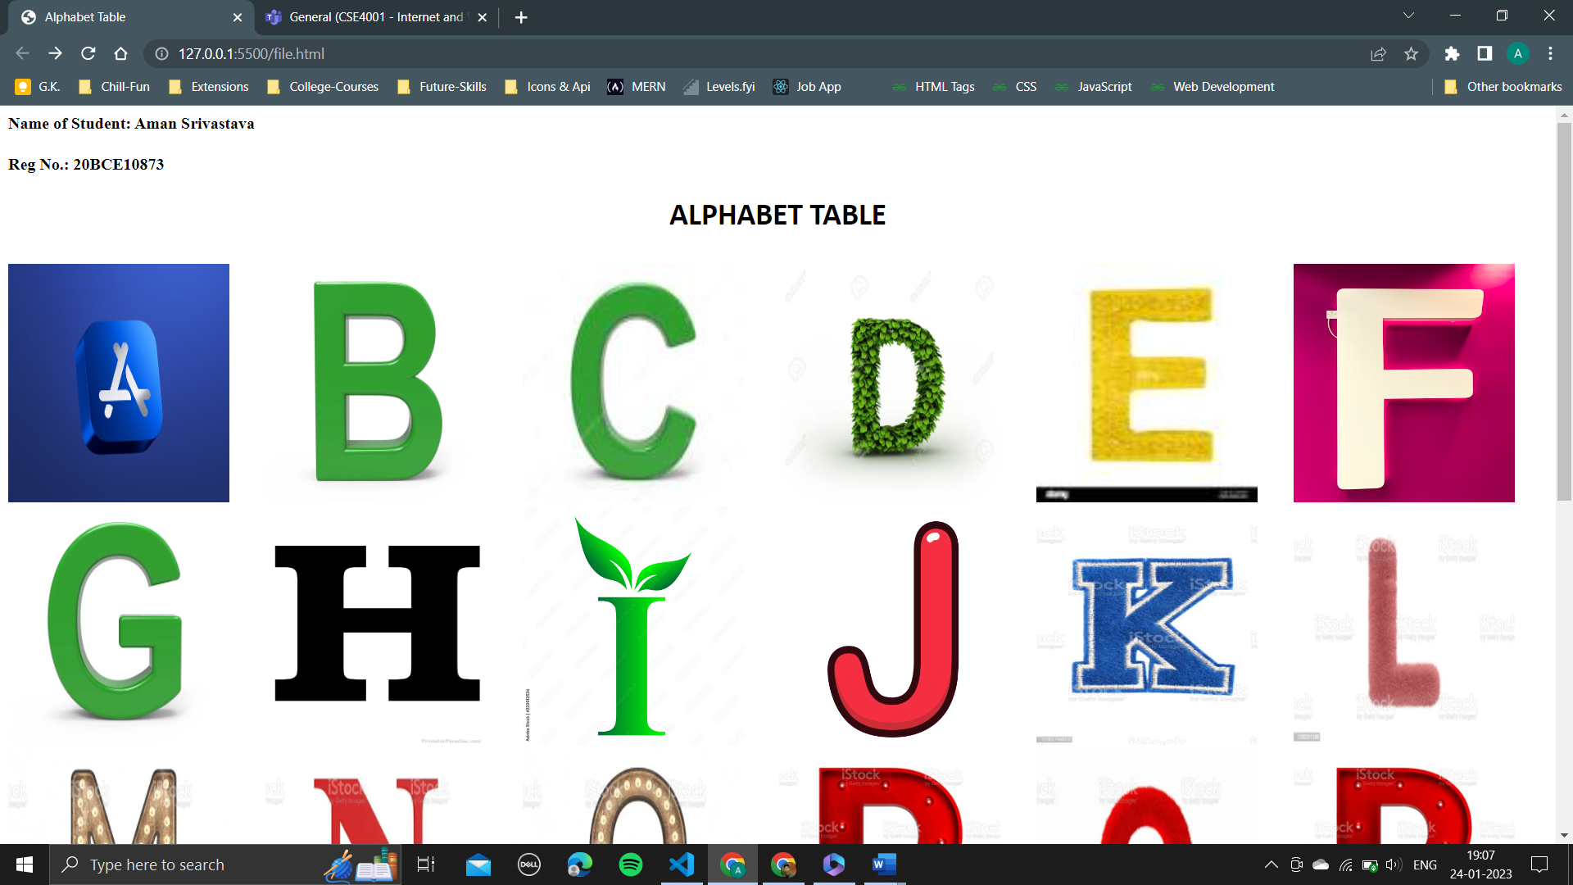

**STEP2: On clicking an alphabet “D” the dog pic will come**

